Signature Identification Using A Custom CNN Model and A Siamese Pre-trained Neural Networks.

Noel Flores
Dept. of Electrical and Computer Engineering
University of Texas at San Antonio
San Antonio, United States
Noel.Flores@my.utsa.edu
Chinwe Aghadinuno
Dept. of Electrical and Computer Engineering
University of Texas at San Antonio
San Antonio, United States
chinwe.aghadinuno@my.utsa.edu

Abstract—In this project, Siamese Networks was employed for handwritten signature verification. The neural networks were models to learn ‘similarity functions’ of the data, rather than classifying each instance directly. The objective is to determine if the two input signature images are of the same person or if it’s a forgery by evaluating their feature embeddings. Our approach explored in this project is development and evaluation of two Siamese Network architectures: one with a custom Convolutional Neural Network (CNN) and another with a pre-trained convolutional model. Modification of the shared pre-trained model was carried out as enable proper verification by computing predicted labels from the model’s dissimilarity outputs and comparing them against true labels. Both models were trained using a total of 2,200 signature data, which was divided into approximately 75% for train data and 25% for test data. Then using contrastive loss, the similarity we embedded the similarity for genuine pairs and dissimilarity for forgeries. After training, the similarity was evaluated using Euclidean distance between embeddings, and a threshold-based decision rule with 0.5 as the threshold value was applied to assess verification performance. Evaluation results indicated that the custom CNN model improved verification accuracy with a 70% accuracy, as in contrast to the pre-trained model which resulted in a 30% accuracy. Also, the custom model was more efficient than the pre-trained model with respect to the convergence speed, highlighting the benefits of task-specified architecture, and optimized decision threshold. This work illustrated the applicability of deep metric learning in biometric verification while also drawing attention to the architectural design considerations of the model for tasks that require similarity measurements.
Keywords—Siamese Network, Signature Verification, Contrastive Loss, Deep Learning, Euclidean Distance, Similarity Learning, Pretrained Model, CNN, Forgery Detection, Embedding Space, and PyTorch.

Introduction
Handwritten signatures as a means of identity verification have been legally recognized and accepted as one of the most widely used forms of biometrics, across multiple domains including banking, administration, and the legal field [1]. However, signature verification has traditionally relied upon a human’s subjective visual inspection, which is highly prone to inconsistencies based on subjective factors such as the verifier’s expertise and fatigue [2]. With forgeries becoming more sophisticated and frequent, there is need for automated systems capable of precise signature verification to supplement or replace routine manual verifications [3]. Unlike conventional classification problems, signature verification is fundamentally a similarity learning problem: the question the system needs to answer is whether the two provided signatures belong to the same person rather than assigning a single signature to a predefined identity class [4]. Siamese neural networks architecture consists of twin subnetworks that learn a common embedding and learn to distinguish input from reference [4]. Thus, it is possible to verify authenticity by checking an input and reference signature pair, confirming that they match. This makes Siamese Networks well-suited for the task.
The goal of this project is to train and evaluate a custom network architecture and pre-trained Siamese Network architecture using a dataset of signature image pairs. The model is trained to classify the pairs as either genuine (belonging to the same person) or forged. After building the custom model, performance assessed and compared to the pre-trained model. Evaluation does not solely focus on accuracy; training duration, and efficiency and variability in the signatures are included as part of the analysis.

Review of the source model
The source model was designed to learn a distance-based similarity metric between pairs of signature images by generating twin embeddings using a shared weight twin network structure. It was implemented using a standard Siamese configuration, where both subnetworks processed 105×105 pixel grayscale input images, and processed them with a deep CNN stack to produce embedding vectors. For evaluating similarity, these embeddings were compared with the Euclidean distance. The selected threshold value was 0.5 which determined whether the pair is genuine or forged. In the first two layers of the model, LRN (local response normalization) and MaxPooling were applied, and in the second layer and beyond, dropout was used. The convolutional stack had 96 filters (kernel size 11) and progressed to 256, 384, and then 256 filters (kernel size 3). ReLU activation function and spatial padding were also included in the architecture. The feature extraction pipeline was followed by fully connected layers, and the output layer produced a two-dimensional embedding vector used for pairwise distance computation. The model was trained using the RMSProp optimizer schedule with a learning rate of 1e-4, momentum of 0.9, and weight decay set to 0.0005. Training was done for 20 epochs with a batch size of 32.
The system operated more like a technical construct that mimicked similarity decisions without performing any real verification of those comparisons. The predicted labels were assigned based on pre-existing file names instead of computed results the model predicted, rather than computed by the model itself, and no comparison between predicted and actual results was conducted.

Methodology
For this project, two variants of Siamese Networks: A self-designed CNN-based Siamese model and a modified version of a pre-trained Siamese model were developed and evaluated. Both models were trained on a dataset consisting of 1,700 pairs of signatures images, and a test set of 500 containing both forged and genuine signatures. For uniformity, all signature images were converted to grayscale and resized to 105 x 105 pixels. To improve generalization, data augmentation techniques such as brightness were applied. DataLoader was also incorporated because of its functionalities to handle batching parallelization during training.
Both networks were implemented on the PyTorch framework. PyTorch ecosystem facilitated efficient model development, training, and testing of Siamese Networks through its modularity and support for dynamic computation graphs.
Several supporting Python libraries were employed, such as;
- NumPy: used for efficient matrix and tensor operations.
- Pandas: used to manage image pair metadata and CSV-based label assignments.
- Matplotlib: used to visualize training loss curves and sample predictions.
- Scikit-learn: used for computing model evaluation metrics, such as accuracy scores and confusion matrices.
This section details the methods applied, architecture and modifications made for the neural networks.

Block Diagram
The block diagram in Fig. 1 represents the overall framework of the Siamese Network incorporated in this project.
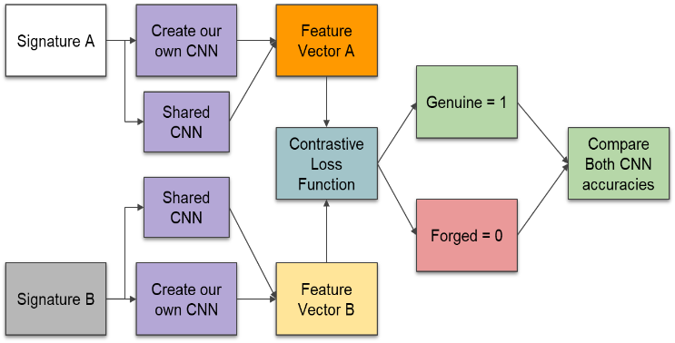
- Block diagram.
Each version - Image Signature A and Image Signature B – was processed through their corresponding branches of the CNN to generate fixed-length feature embeddings known as Feature Vector A and Feature Vector B. As mentioned in previous section, these embeddings are then loaded into a contrastive loss function, which considers the Euclidean distance calculated between the feature vectors.
Training was performed with either the Adam or RMSProp optimizer, while the model evaluation was based on empirically optimized dissimilarity thresholds. Using the calculated Euclidean distance and a certain threshold, the model was trained to correctly identify genuine pairs (signatures from the same individual labeled as 1) and forged pairs (signatures from different individuals marked 0). After the training stage, the verification accuracy performance is evaluated.

Modification of the Pre-Trained Siamese Network Model.
The source Siamese model the model did not compute, or output predictions based on learned embeddings; rather, it passively inherited ground-truth labels from the dataset for display purposes. Furthermore, no logic was implemented to generate predicted labels, compare them with true labels, or assess the model’s actual verification ability. Additionally, performance metrics such as accuracy and confusion matrices were absent, making it impossible to evaluate the model’s effectiveness.
To overcome these constraints, modifications were made. Proper verification logic was included. The model uses shared convolutional layers to generate embeddings for each input signature, subsequently calculating the Euclidean distance between the embeddings of a signature pair. The expected outcomes—based on true dataset values—identifying the computed labels, allow performance evaluation through accuracy scores.
In terms of architecture, the deep CNN stack influenced by the AlexNet-like configurations was preserved in the modified pretrained model. It included four convolutional layers with progressively deeper and more intricate ReLU activations alongside local response normalization (LRN) max pooling and dropout layers to mitigate overfitting. This extraction pipeline was followed by a projection head fully connected across three dense layers, which projects the high-dimensional feature maps into a 2-dimensional embedding vector designated for pairwise distance computation and comparison.
The model was trained with the following configuration:
- Optimizer: RMSProp.
- Learning Rate: 1e-4.
- Momentum: 0.9.
- Weight Decay: 0.0005.
- Epochs: 20.
- Batch Size: 32
These changes elevated the pre-trained model from a rigid, skeletal structure to a fully integrated Siamese verification model that performs pairwise dissimilarity computation, and accuracy assessments.

Proposed Custom Siamese Network Model.
In this project, we explore a more tailored and efficient method for signature verification, a custom Siamese Network was developed using a convolutional model based on ResNet (a well-known CNN) design paradigm. ResNet employs residual connections which allows effective training of deeper networks, making it particularly useful for tasks involving complex representations like signature similarity estimation.
Each signature image undergoes a ResNet-like feature extractor, where the final classification layer is replaced by a projection head. This consists of two fully connected layers: a ReLU-activated 512-to-256 transformation, and a second linear layer projecting 256 to a 64-dimensional embedding vector. The higher-dimensional embedding space was chosen to allow the network to capture finer differences for genuine and forged signatures compared to the pretrained model’s 2-dimensional embeddings.
In order to improve learning behavior of the model, some fundamental training parameters were adjusted. Firstly, the batch size was changed from 32 to 16. By decreasing the batch size, there was an increase in the number of weight updates per epoch adding a degree of stochasticity to gradient computation. This modification helped avoid sharp local minima and enhanced generalization. Secondly, the number of epochs was increased from 20 to 40, allowing more time and training cycles for the custom architecture to adequately exploit the solution space and optimize contrastive separation. Lastly, the optimizer was changed to Adam due to its adaptive learning rate and momentum handling, in contrast to the RMSProp optimizer used previously. Custom, complex architectures benefit more from Adam because of the need for less extensive manual tuning.
Data augmentation was performed by modifying brightness and contrast of the images using ColoJitter. All signature images were resized to 105x105 pixels and reformatted to 3-channel mode to fit as input. The verification logic was not changed from the method used in the pretrained model. However, in this case the optimal threshold was determined by evaluating the model across a range of possible distance values. The custom model was assessed using model performance evaluation which included confusion matrix analysis and model accuracy.
The next section shows the results of the custom siamese network model and its comparison to the pretrained model.

Results.

Modified Pre-Trained Siamese Network Model
For the pretrained model, after implementing architectural adjustments, the model was trained using GPU. The accuracy was low, with a training accuracy of approximately 32%, and a prediction accuracy of around 30%. The processing time surpassed 2 hours, highlighting inefficient training.
For the prediction, 10 samples from each of the data sets (original and forged) were used, and to visually understand what the results are reporting, a confusion matrix was added to the analysis, as seen in Fig. 2 below.
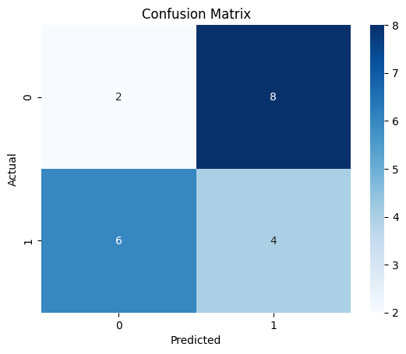
- Pre-trained Model Confusion Matrix.
The figure above shows that out of ten(10) original signatures, the model misclassified eight (8) as ‘forged’. Also, out of ten (10) forged signatures, the model misclassified six (6) as ‘original’. This error rate confirms that the model failed to learn a robust decision boundary. They were most likely due to over-constrained embedding spaces as well as restrictions on useful feature divergences for model training.
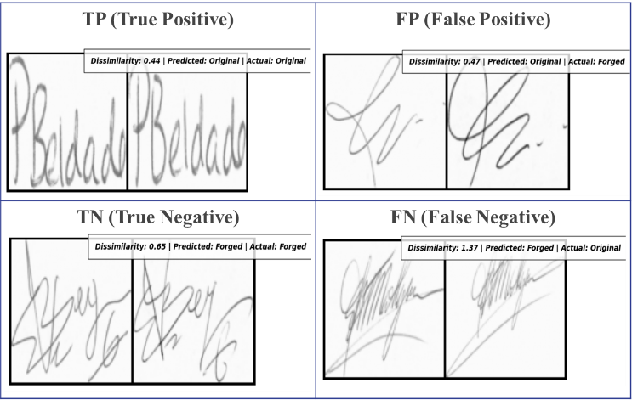
- TP, TN, FP and FN Sample of the Pre-trained Model.
By further evaluating sample of the True positive (TP), True Negative, False Negative (FN) and False Positive (FP), as seen in Fig. 3 above, further demonstrates model failure where forged and original signatures crossed threshold boundaries incorrectly.

Custom Siamese Network Model.
For the custom model, after implementing architectural adjustments, the model was trained using GPU. The custom Siamese model achieved a training accuracy of approximately 66% and a prediction accuracy of 70%. The processing time was approximately 1 hour which demonstrates improvement toward efficiency and performance.
From the prediction, 8 samples of the original and 14 samples of the forged were used. To visually understand what the results are reporting, a confusion matrix was also used to analyze, as seen in Fig. 4 below.
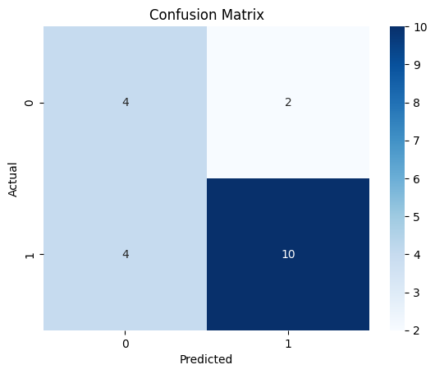
- Custom Model Confusion Matrix.
The figure above shows that out of ten(8) original signatures, the model misclassified two (2) as ‘forged’. Also, out of ten (14) forged signatures, the model misclassified four (4) as ‘original’. Further evaluating sample of the True positive (TP), True Negative, False Negative (FN) and False Positive (FP), as seen in Fig. 5 below, the results indicate that the custom model more effectively separated genuine and forged pairs, particularly in challenging edge cases.
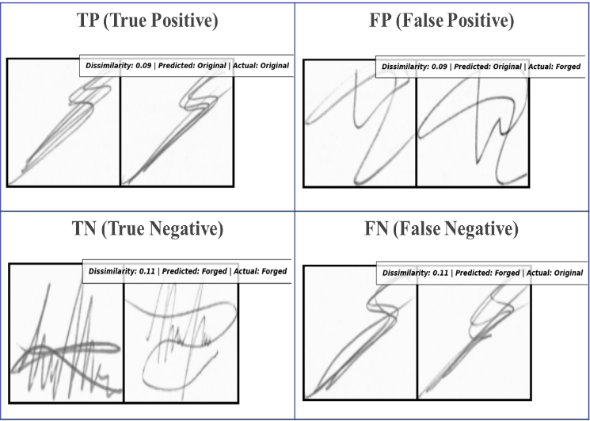
- TP, TN, FP and FN Sample of the Custom Model.
The extended training, data augmentation and increased embedding size improved contributed to more accurate and stable decision-making across diverse handwriting styles. In general, the custom model showed better discrimination of signature authenticity and greater tolerance of changes in writing style, stroke thickness, and spatial orientation, confirming the benefits of architectural and hyperparameter refinements.

Overall Results Evaluation.
The two models were compared based on their architecture, training configurations, and performance metrics. Table 1 below summarizes the results and the parameters of the models.

- The models overall evaluation
Model | Embed.  Size | Epoch | Batch Size | Opt. | Acc (%) | Run Time
Pre-Train Model | 2 | 20 | 32 | RMSProp | 30 | 2hrs : 36mins
Custom Model | 64 | 40 | 16 | Adam | 70 | 1 hour

These results confirm that the custom model performance is better throughout all metrics of estimation, training effectiveness, and generalization. The pretrained model poorly identifies authentic signatures and forged signatures, while the custom model sustained a more stable threshold margin and higher correctness across both classes.

Summary and conclusion

Summary.
In this project, we successfully implemented two Siamese Network models for handwritten signature verification: a modified pretrained CNN model and a self-developed CNN model. The model evaluated the model’s ability to learn meaningful embeddings and verification of the authenticity of signature samples. The pre-trained model, due to its limited embedding dimensions and architecture, performed poorly with generalization, resulting in poor verification accuracy. The proposed custom model, which was developed using ResNet inspired architecture and a 64-dimensional projection, resulted in a more accurate model, with more efficient convergence and a better generalization. Overall, the custom Siamese Network proved to be more effective and robust than the pre-trained model, for signature identification.

Conclusion
In conclusion, this project not only met its primary objective of building a functional and accurate signature verification system, but also offered valuable insights into how architecture design, training strategies, and evaluation frameworks impacts model performance. Both models were based on the same architecture consisting of twin subnetworks with shared weights, yet their performance diverged due to differences in models’ depth, embedding size, and regularization techniques. The pretrained model could not capture complex handwriting variations, while the custom model, on the other hand, performed better with verification with a deeper structure, shorter training times, and more frequent weight updates.

Limitations/future improvement ideas
The data set in this project was limited as it didn’t include a wide variety of writers, along with highly controlled environmental conditions. Adding larger and more diverse datasets, along with signature conditions and forgeries would further improve the model’s generalization and robustness. Additionally, exploring methods for model optimization that involve quantization and pruning opposed to retaining accuracy for real world application would be another necessity. With reliance on adaptive decision-making thresholds, fixed thresholding could also be done for adjusting input quality and sensitivity.

Acknowledgment
I am deeply grateful to the instructor of the Brain Inspired A.I class, and the teaching assistants that contributed to the completion of this project. I also wish to extend my thanks to the University of Texas at San Antonio for providing resources and guidance.

References

- D. Impedovo and G. Pirlo, “Automatic Signature Verification: The State of the Art,” IEEE Transactions on Systems, Man, and Cybernetics, Part C (Applications and Reviews), vol. 38, no. 5, pp. 609–635, Sep. 2008, doi: https://doi.org/10.1109/tsmcc.2008.923866
- T. P. Team, “Signature Verification: Man vs. Machine,” Parascript, Mar. 28, 2013. https://www.parascript.com/blog/signature-verification-man-vs-machine/ (accessed May 09, 2025).
- “CivicPlus Headless CMS,” Civicplus.com, 2025. https://content.civicplus.com/
- E. Team, “Similarity Learning with Siamese Networks,” Great Learning Blog: Free Resources what Matters to shape your Career!, Dec. 17, 2020. https://www.mygreatlearning.com/blog/siamese-networks/ (accessed May 09, 2025).
- Robinreni, “Signature Classification Using Siamese (Pytorch),” Kaggle.com, Jan. 31, 2019. https://www.kaggle.com/code/robinreni/signature-classification-using-siamese-pytorch/notebook (accessed May 10, 2025).

